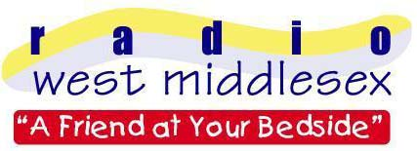
Radio West Middlesex

c/o West Middlesex University Hospital

Twickenham Road

Isleworth

Middlesex TW7 6AF

PRESS RELEASE

TOP TEN TALENT!

Date: 4th April 2005

Radio West Middlesex, the Radio Station for patients at Isleworth’s West Middlesex Hospital has been commended as one the top Hospital Radio stations in the UK.
Nearly 300 hospital radio stations were invited to enter the annual awards and this year the Station of the Year category is sponsored by BBC Radio 2.
The station entered the awards with a 15 minute documentary about its work, including programme extracts and interviews with hospital patients and members of RWM.
The winners of this years National Hospital Radio Awards were announced during an awards ceremony at the Europa Hotel in Belfast on Saturday 2nd April 2005 which also launched this years’ Hospital Broadcasting Week.
The award recognises the quality of service of each individual station and the programmes, which they broadcast.
Radio West Middlesex chairman, Alan Hardy said, “We’re thrilled and honoured to be recognised once again for the quality of our service and programmes at Radio West Middlesex. Being judged to be among the best hospital radio stations in the country is a tribute to all our members who willingly give their time and talents week by week. This will give us added enthusiasm as we continue our work of cheering and entertaining the patients in West Mid.”

If you wish to cheer someone up currently in the hospital by requesting their favourite tune, you can do so by logging on to www.radiowestmiddlesex.org.uk or telephone 020 8321 5166 at any time.

- PRESS RELEASE ENDS –

- The RWM entry can be heard online at www.radiowestmiddlesex.org.uk
- Radio West Middlesex is the voluntarily run Hospital Radio Station of the West Middlesex University Hospital.
- The station is a registered charity and has been operational since 1967.
- For further details please contact James Hoff (Press officer) on 0208 939 5317 or 07905 503089
- Radio West Middlesex is a registered charity, number 1050841.

