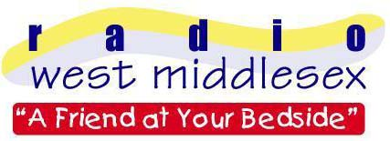
Radio West Middlesex

c/o West Middlesex University Hospital

Twickenham Road

Isleworth

Middlesex TW7 6AF

PRESS RELEASE

We’re Ten Of The Best!
Date: 8th March 2005

Radio West Middlesex, the Radio Station for patients at Isleworth’s West Middlesex Hospital has been nominated as one the top Hospital Radio stations in the UK.
Nearly 300 hospital radio stations were invited to enter the annual awards and this year the Station of the Year category is sponsored by BBC Radio 2.
The station entered the awards with a 15 minute documentary about its work, including programme extracts and interviews with hospital patients and members of RWM.
The winners of this years National Hospital Radio Awards will be announced during an awards ceremony at the Europa Hotel in Belfast on Saturday 2nd April 2005 launching this years’ Hospital Broadcasting Week.*
The award recognises the quality of service of each individual station and the programmes, which they broadcast
Radio West Middlesex volunteer, James Hoff said, "To be nominated for an award which places Radio West Middlesex as one of the top ten stations in the country is fantastic”.
"We try to ensure that programmes give a wide choice of listening to our patients, not only providing information, requests and favourite music but also serving the hospital community too. It is extremely rewarding for our service to be recognised at a national level."
The RWM entry can be heard online at www.radiowestmiddlesex.org.uk including more information on the station, Hospital Broadcasting Week and how to dedicate a request.
*** ENDS ***
*Radio West Middlesex, the Radio Station for patients at Isleworth’s West Middlesex Hospital, will be helping promote Hospital Broadcasting Week 2nd-10th April 2005. Special programmes will mark the event and a display will be positioned in the hospital atrium. More information to follow.

- Radio West Middlesex is the voluntarily run Hospital Radio Station of the West Middlesex University Hospital.
- The station is a registered charity and has been operational since 1967.
- For further details please contact James Hoff (Press officer) on 0208 939 5317 or 07905 503089
- Radio West Middlesex is a registered charity, number 1050841.

