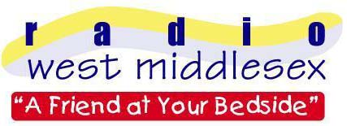
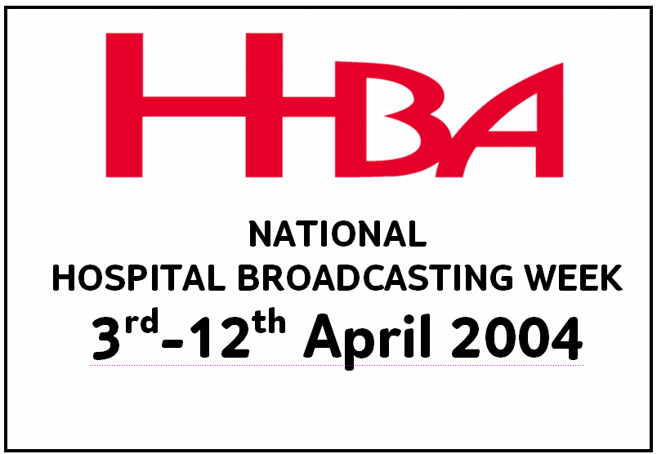 Radio West Middlesex

c/o West Middlesex University Hospital

Twickenham Road

Isleworth

Middlesex TW7 6AF

PRESS RELEASE

NATIONAL HOSPITAL BROADCASTING WEEK

Date: 19th March 2004

Radio West Middlesex, the Radio Station for patients at Isleworth’s West Middlesex Hospital, will be helping promote Hospital Broadcasting Week. 3rd-12th April 2004.

Hospital Broadcasting Week 2004 puts the spotlight on the work of around 260 local hospital radio stations that operate in the UK. The hospital’s own station will be promoting the event by launching its newest programme; an hour of nostalgic music from the 40’s and 50’s. The station will also be displaying a special information board in the atrium during the week.
During the week, stations are being encouraged to promote their work in their hospitals and local communities. It's an opportunity for them to gain new listeners, to attract new volunteers or sponsors, or to say thank you to their existing dedicated supporters.

James Hoff – station volunteer said; “Hospital Broadcasting Week will highlight the hard work thousands of volunteers contribute to hospitals nationwide. Hospital Broadcasting enables patients to see a friendly face for a chat at their bedside, having the opportunity to listen to their favourite music as well as taking part in programmes. It can really help them to keep in touch with their community”

- Radio West Middlesex is the voluntarily run Hospital Radio Station of the West Middlesex University Hospital.
- Hospital Broadcasting Week logo mast attached.
- The station is a registered charity and has been operational since 1967.
- For further details please contact James Hoff (Press officer) on 0208 939 5317.

