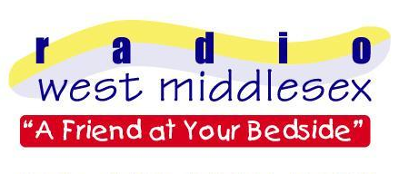

Radio West Middlesex

c/o West Middlesex University Hospital Twickenham Road

Isleworth Middlesex TW7 6AF

PRESS RELEASE

‘Frank Still Swings, But Robbie’s Not Winning’

For patients at the West Middlesex Hospital 2006 was the year when Robbie Williams seemed to go out of fashion. When Radio West Middlesex counted up all the requests asked for by patients during the year, Robbie’s song ‘Angels’ was the biggest faller on the annual top twenty request countdown. Meanwhile Frank Sinatra not only stays top, but ‘My Way’ was asked for by 69% more patients than last year.

Other favourites among patients include Bette Midler’s ‘Wind Beneath My Wings,’ Queen’s ‘Bohemian Rhapsody’ and the ever popular’ Nessun Dorma’.

The chart, compiled annually, reflected the huge range of music played throughout the year on the radio station based at West Mid. During 2006 volunteers at the station collected and played nearly 1,400 requests, one of the highest totals in over ten years.

If you wish to cheer someone up currently in the hospital by requesting their favourite piece of music, log on to www.radiowestmiddlesex.org.uk or telephone 020 8321 5166 any time.

- PRESS RELEASE ENDS -

Note to editors
- Radio West Middlesex is the voluntarily run Hospital Radio Station of the West Middlesex University Hospital.
- The station is a registered charity and has been operational since 1967.
- For further details please contact James Hoff (press officer) on 07905 503089

