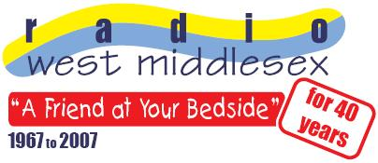

Radio West Middlesex
West Middlesex University Hospital
Twickenham Road
Isleworth
Middlesex TW7 6AF
Radio West Middlesex On 87.7 FM

From Thursday 22nd to Monday 26th November people in the local area will be able to tune into Radio West Middlesex too. It’ll be broadcasting on 87.7FM to let those outside the wards hear what they get up to and for patients, friends and relatives to send each other requests.

On Thursday, listeners will be able to hear a typical day's broadcasting for patients in the hospital. From Friday to Monday, the station will present a special weekend schedule which will include regular shows alongside anniversary editions of programmes presented by past members returning to the Radio West Middlesex airwaves. Patients, ex-patients and relatives at home will be able to exchange requests and messages in many request shows planned.

Presenters will be visiting the wards talking to patients, relatives and staff throughout the weekend. Studio guests will reflect activities both inside the hospital and in the local area, including live reports from Sunday's Whitton 'Christmas Extravaganza'. The station will revive the 'Talking Point' evening local news programme, 'Now You Has Jazz' and 'The Classical Collection' and others. Listeners will also be able to hear a special show with country legend Don Williams and a documentary on how the local area has helped shape pop music from the late 1950s.

From an initial weekly one hour request programme, Radio West Middlesex now provides a 24 hour service, with over 25 volunteers visiting patients in the wards and presenting programmes. A mix of record requests, special interest programmes, hospital and local information along with relaxing music is made available to patients on their bedside entertainment systems. The station estimates that since 1967 its members have visited and played the musical choices of well over 40,000 patients!

You can find out more about Radio West Middlesex on the station’s website www.radiowestmiddlesex.org.uk

Press Release ends---------

Contact – James Hoff 07905 503089 (Press and Publicity) or Alan Hardy (Programme Controller/Chairman – 0208 321 5166)

